Procedural unit codebook figures.

(V.1.0) Git commit [b890114] 2020-09-21

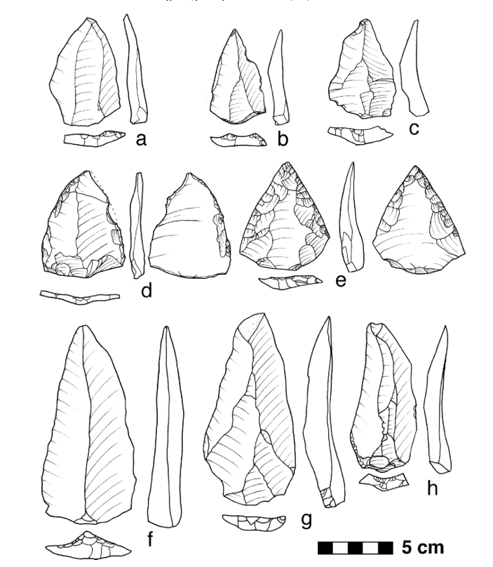

Figure 1. Figure 23 illustrating levallois point variation from Kibish formation (Shea, 2008).

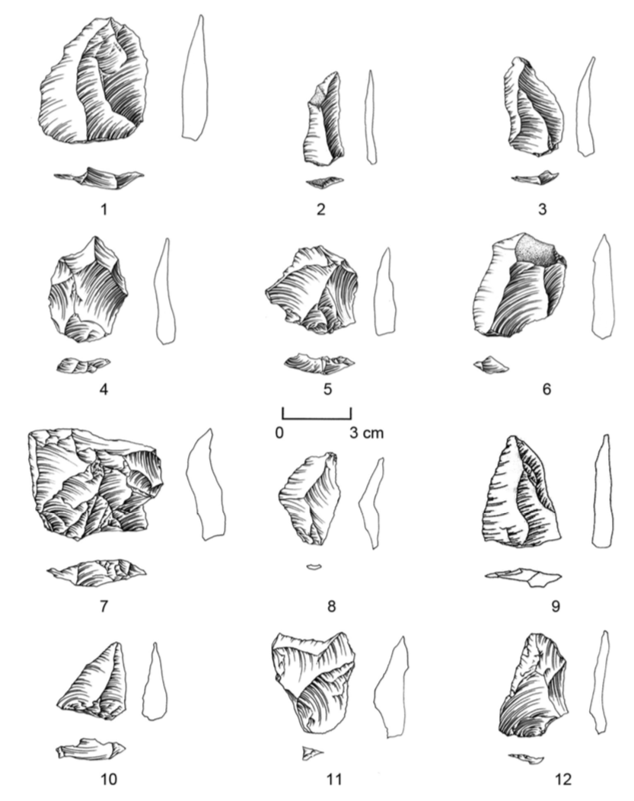

Figure 2. From figure 5 illustrating levallois flake and centripetal flake diversity (Picin & Vaquero, 2016).

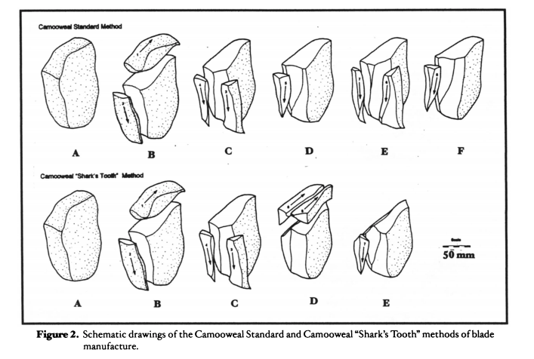

Figure 3. Figure 2 illustrating schematic drawings of blade manufacture methods in Queensland (Moore, 2003).

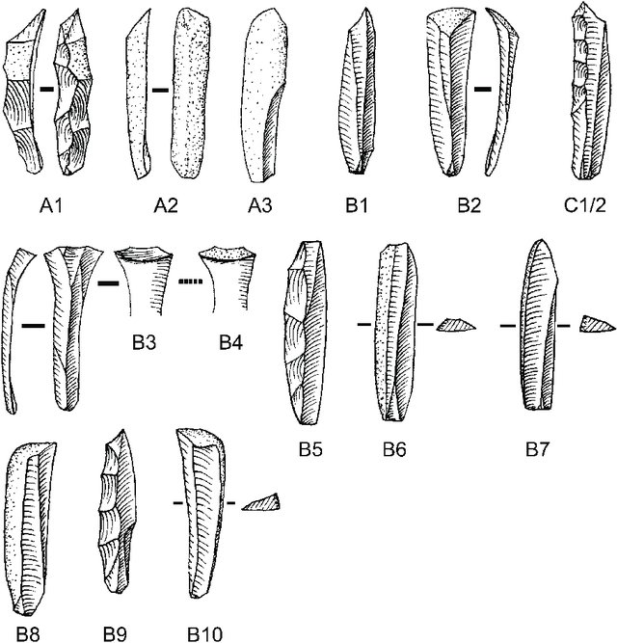

Figure 4. Figure 4 on technological blade classifications at Rose Cottage Cave (Soriano et al., 2007).

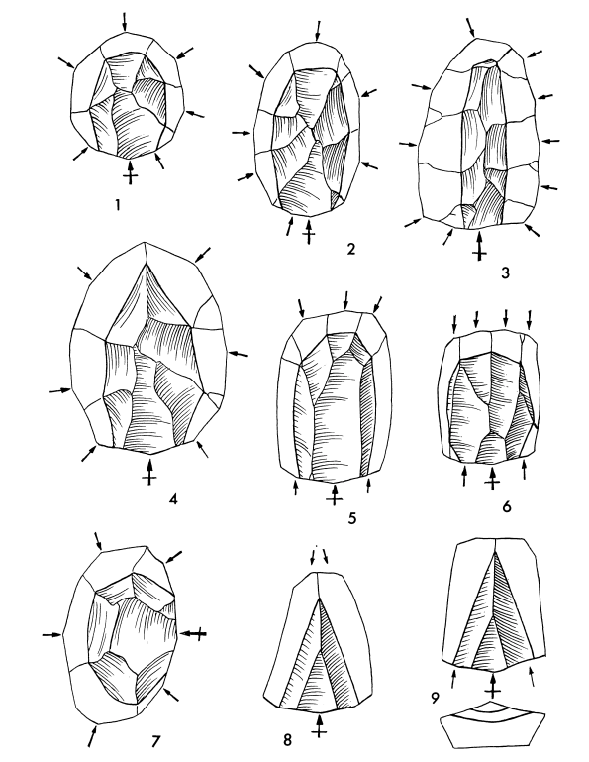

Figure 5. Figure 1 in in description of Levallois technology (Bordes, 1980).

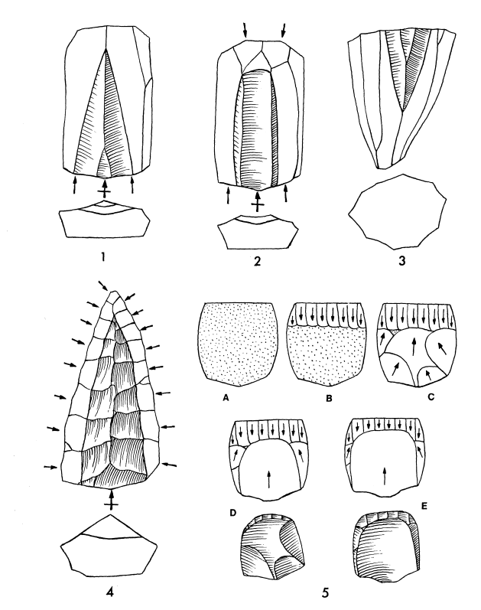

Figure 6. Figure 2 in description of Levallois technology (Bordes, 1980).

Figure 7. Figure 5 description of bladelet core preparation at ‘Ein Qashish with distal preparation at step 4.(Malinsky-Buller et al., 2014)

Figure 8. Figure 2. Schematic illustrating busqued burin production methods at La Ferrassie (Chazan, 2001).

Figure 9. Figure 2. Microblade core variability at Amakomanak.(Coutouly, 2017)

Figure 10. Initial blade subtypes from Kfar HaHoresh (Barzilai & Goring-Morris, 2010).

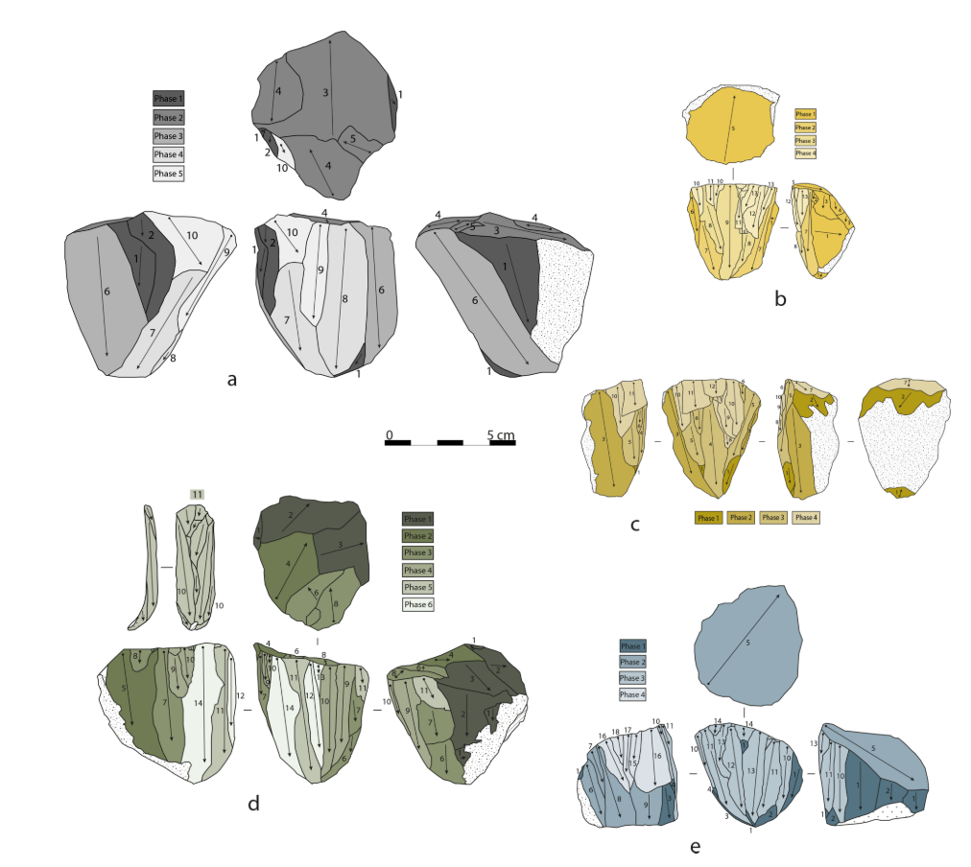

Figure 11. Figure 4 in description of blade cores from Fumane cave (Falcucci & Peresani, 2018).

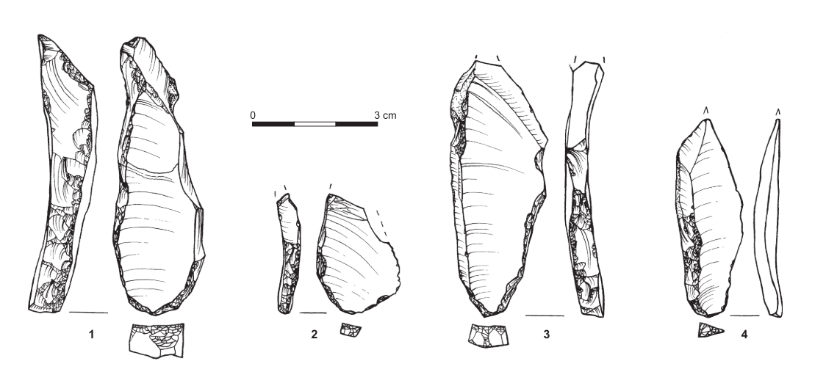

Figure 12. Figure 14 illustrating platform spalls from bidirectional blade cores recovered from Kfar HaHoresh (Barzilai & Goring-Morris, 2010)

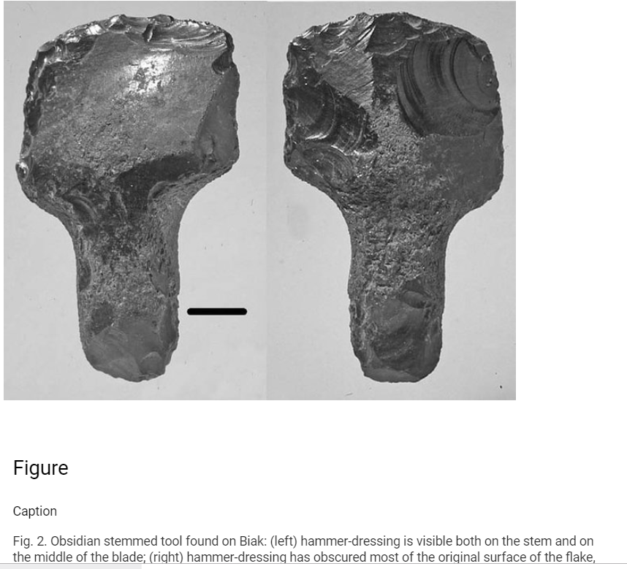

Figure 13. Figure 2 illustrating hammer dressing on stemmed obsidian tool from Biak Island, West Papua (Robin Torrence et al., 2009).

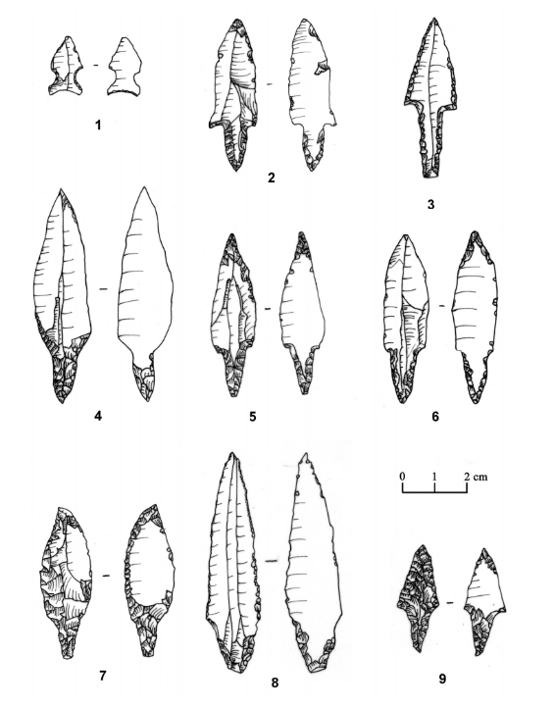

Figure 14. Figure 13 illustrating projectile points recovered from Motza (Khalaily et al., 2007).

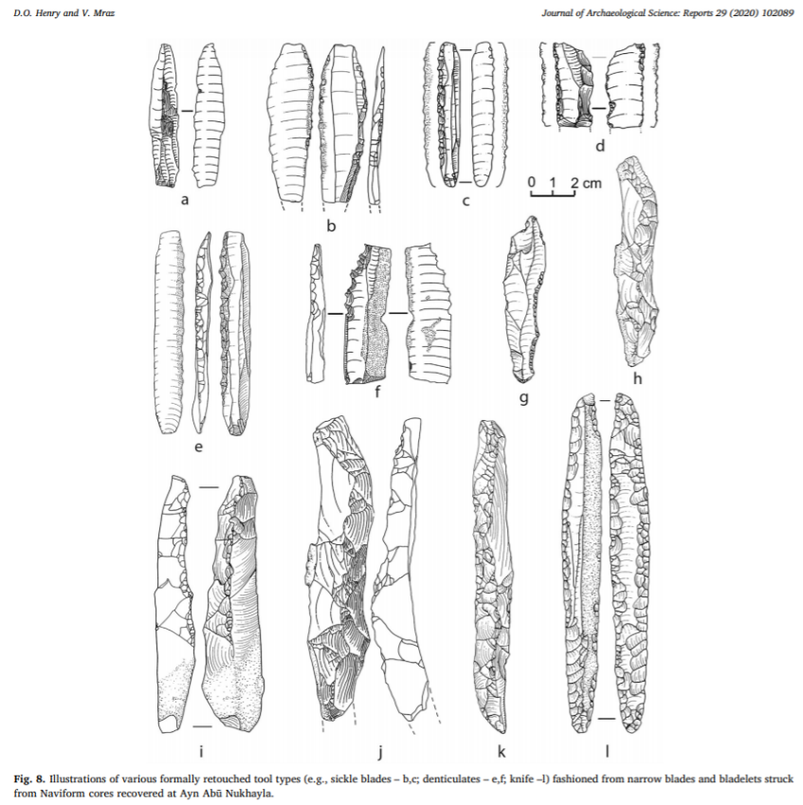

Figure 15. Figure 8 illustrating some retouched tool tyles from Ayn Abu Nukhayla (Henry & Mraz, 2020).

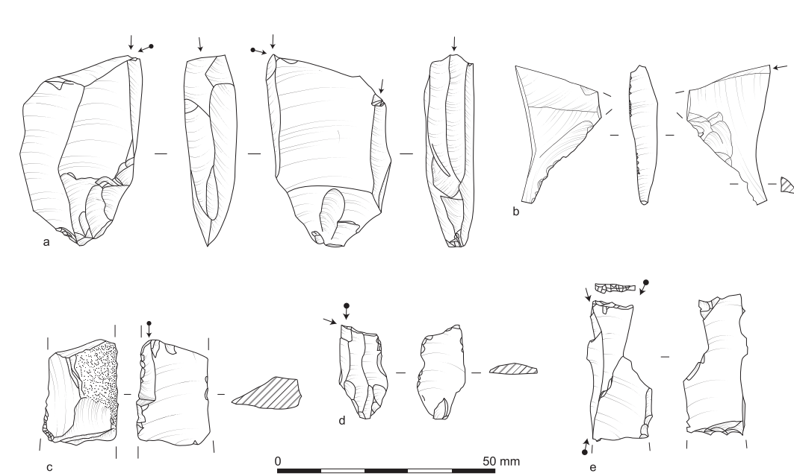

Figure 16. Figure 5 illustrating burin variation at the PPNA site El Hemmeh (Smith et al., 2016).

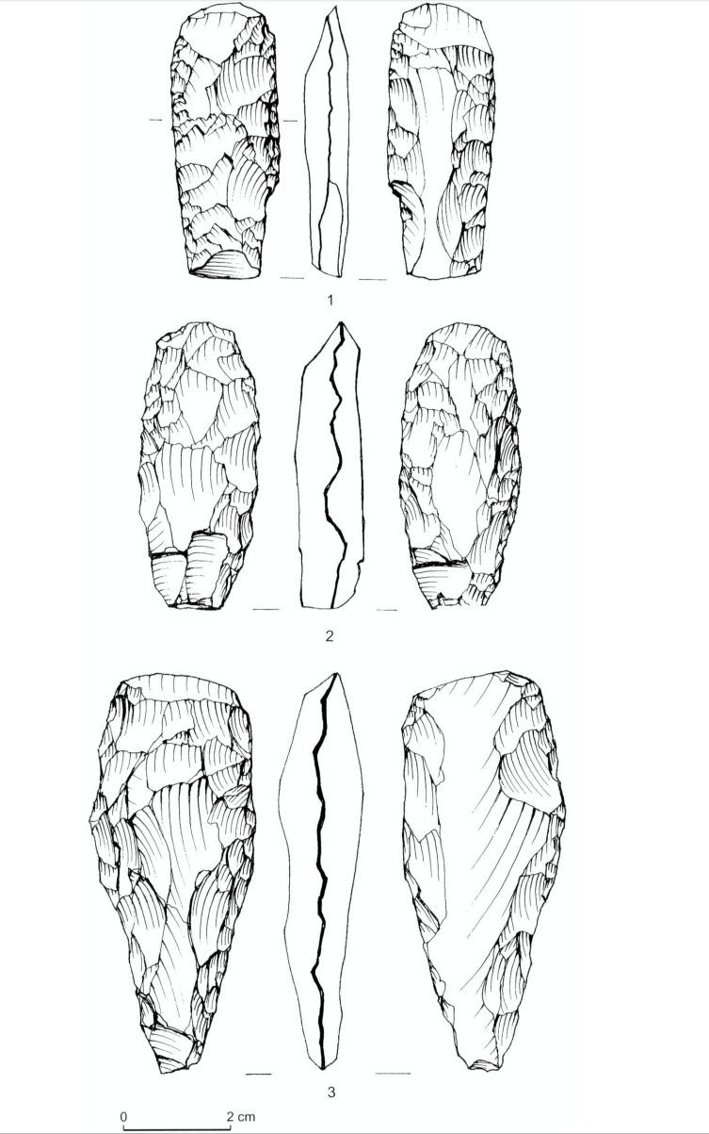

Figure 17. Figure 14 illustrating tranchet axe variability at Motza (Khalaily et al., 2007).